University of Dublin



TRINITY COLLEGE

Tracking Public Attitude Towards the Garda using Sentiment Analysis

Ciarán McGarry
B.A.(Mod.) Computer Science
Final Year Project April 2019
Supervisor: Prof. Khurshid Ahmad

School of Computer Science and Statistics

O’Reilly Institute, Trinity College, Dublin 2, Ireland

DECLARATION

I hereby declare that this project is entirely my own work and that it has not been submitted as an exercise for a degree at this or any other university

______________________________________________ ________________________
Name Date

Permission to Lend

I agree that the Library and other agents of the College may lend or copy this thesis upon request.

_____________________________________________________
Name

Acknowledgements

I would like to thank Prof. Khurshid Ahmad for providing direction on this project, Shane Finan for his invaluable advice and feedback, as well as all my family and friends for making what should have been a very stressful year thoroughly enjoyable.

Abstract

The aim of this project is to create a tool built upon sentiment analysis techniques for the tracking of public attitude towards the Garda in Irish newspapers, so that a Garda Press Officer may quickly and intuitively gauge public perception on a given day.

List of Tables

Contents

Introduction

Opinions, be they based on sound truth or unsound truth, falsehood or superstition, are central to human activity and key influencers of behaviour. The clothes we wear, the food we eat, the choices we make, all are informed to some degree by the way in which others perceive and evaluate the world. A natural step in our decision-making process is to seek out the opinions of others before making a commitment. The perspective of others holds importance not only for individuals but also for organisations. The rapid growth of mass media and the explosion of social networks mean previous methods of tracking public attitudes have grown too slow for the information age. The modern problem of matching the rate at which media is produced with our ability to digest and categorise said media is a great one, and so enters the field of sentiment analysis.
Sentiment analysis is generally concerned with deriving, from a piece of text, the attitude of the author towards a topic within that text, then quantifying that attitude within the context of its domain. Also termed “opinion mining”, “mood extraction”, and “emotion analysis”, sentiment analysis builds upon natural language processing tools and techniques in order to identify pertinent information in the source text and analyse it to produce a polarity score, which may simply be binary (positive or negative), a Z-score measure of deviations from the norm, or some point on a continuous scale (-1 for wholly negative and 1 for wholly positive).
Though sentiment analysis has been defined as “a process of determining whether a piece of information is positive, negative, or neutral” (Mira Dholariya, Dr.Amit Ganatra, Prof. Dhaval Bhoi, 2017), by adjusting the dictionary and categories used for analysis it can in fact identify a wide range of properties of a source text, such as strong or weak, active or passive. In this way we can greatly extend the application areas of the field.
For example, a person interested in buying a new computer game may first seek the public or critics’ reviews on it, to make an informed decision on whether the game is worth spending money to play. In this situation, a sentiment analysis tool could be employed to automatically evaluate the sentiment of a review towards the game. This could then be scaled up to provide an average sentiment based on the general sentiment of the reviewing audience in a way that manual reading and gauging would struggle to do in an efficient time-scale.
Another area in which our specially configured sentiment analyser (one in which our dictionary refers not only to categories of positive and negative) could see service is in the political sphere. Take for example an important politician giving a public speech following a disaster. The politician’s background team, and the politician themselves, may read over the speech to determine whether the vocabulary is sufficiently strong, or overly passive, for the circumstances. A sentiment analyser set up to score the properties of strong and passive could help in quickly assessing the text, providing polarity scores to be compared with previous speeches the politician has given. Indeed, this application could also be scaled up to provide an overarching view of the rhetoric of a political party, as well as their opponents, to ensure for the parties Press Officers that the right notes are being struck on key issues across the board.
Though sentiment analysis is a relatively young field, the latest eruption in online media has made the potential fruits of its labours plain to see, leading to great strides in forward in recent years. Ronen Feldman (2013) defines five distinct areas of sentiment analysis which must each be dealt with in order to produce coherent and effective results. These are:

Document-Level Sentiment Analysis
The “simplest form of sentiment analysis”, this treats the document in question as containing a single opinion on one main topic. The most coarsely-grained approach, but useful for gaining a broad stroke understanding of a document’s sentiment.

Sentence-Level Sentiment Analysis
For a more finely-grained view of the documents attitude, sentence-level analysis assumes there is a single opinion per sentence and that the identity of the subject is known. Most approaches analyse only subjective sentences, but some deal also with objective statements, which are more difficult.

Aspect-Based Sentiment Analysis
The previous approaches work well when a document or sentence contains a single opinion on an entity e.g. “I like the car”. However, oftentimes people have varying opinions on different properties (aspects) of an entity, such as of a new car: “The handling is great, but it accelerates poorly’. Classifying this statement as either positive or negative towards the car would disregard valuable information it contains. Aspect-based sentiment analysis is a finely-grained approach which recognises all sentiment expressions within a document and the aspects to which they refer, and home to a wide range of difficult sub-problems, such as aspect identification and unification.

Comparative Sentiment Analysis
This area of sentiment analysis focuses on the identification of comparative opinions, and the extraction of preferred entities within them. Using a relatively small number of comparative (‘more’, ‘less’, ‘better’) and superlative (‘most’, ‘least’, ‘best’) adjectives, as well as some additional phrases (‘favour’, ‘superior’, ‘prefer’), we can cover the vast majority of comparative cases.

Sentiment Lexicon Acquisition
A database of words for the performing sentiment analysis, the sentiment lexicon is “the most crucial resource for sentiment analysis algorithms”. The lexicon can be compiled in a variety of manners: manually, in which the database is coded by hand; dictionary-based, in which the database is derived from a set of seed words using pre-existing dictionaries; and corpus-based, in which a set of seed words is expanded using a large corpus of documents from a single domain. The most suitable method depends on the labour involved and whether a domain-specific or domain-independent lexicon is needed.

In each of these problem areas the solutions can be divided between two approaches: supervised and unsupervised.

- Supervised learning first assumes a finite set of possible classifications for a text – the simplest case being positive and negative. Given a training data set and a classification algorithm, such as a Support Vector Machine (SVM) or Naïve Bayes, a model for classifying is learnt and used on new text to sort it into one of the assumed possible categories. While more advanced versions will make use of language structure and sentiment lexicons, this method provides good accuracy even with a bag-of-words level of representation.
- Unsupervised learning is usually based on evaluating the semantic orientation of specific words and phrases within the text. Which category the text is classed as is dependent on the derived value being found to lie within some prescribed threshold.

As work in sentiment analysis continues, the field has become increasingly defined despite its youth. Bing Liu (2012) in his book “Sentiment Analysis and Opinion Mining” sets out, among other things, the problem areas this branch of study is faced with, such as spam detection, objective and comparative statements, implicit and explicit opinions, and the issue of perspective. The last-most issue is particularly tricky as a single statement (such as “house-prices are going down”) maybe be seen as negative by some (house sellers) and positive by others (house buyers).
As well as describing methods by which these stumbling blocks may be overcome, and scope for improvement in the future, Bing Liu (2012) lays out the application areas suitable for sentiment analysis such as “consumer products, services, healthcare, […] financial services […] social events and political elections”. It is believed by many that sentiment analysis tools may be of use to some degree in “every possible domain”. This ambitious forecast of the future is further expanded by Mira Dholariya, Dr.Amit Ganatra, Prof. Dhaval Bhoi (2017) who further detail the various use-cases of sentiment analysis and survey the diverse tools and techniques in use today, in particular EMOTICONS, SentiStrength, SentiWordNet, and SenteNet to name but a few.
As this research exemplifies, sentiment analysis has clearly experienced great strides forward in recent years, but how many of its vast application areas have seen the fruits of its labour? It is quite one thing to provide the potential for change, and another thing to provide change itself, and the newness of sentiment analysis has meant its adoption has not yet propagated through all the domains to which it could be applied.
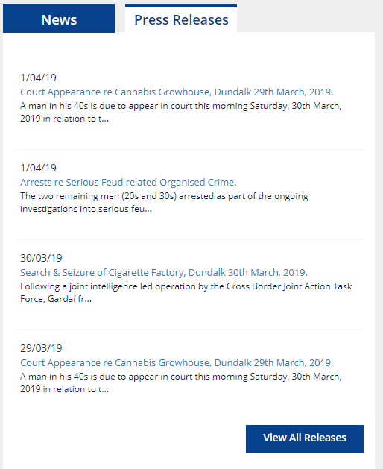
Take for example the Garda police force, as a branch of the Irish government they are funded by taxpayer money, meaning the performance of the Garda is in the public interest. As a result, the evaluation and management of public opinion is also in the Garda interest. In pursuit of this aim the Garda send out regular press releases which control the supply of information to the media. But how to determine whether these press releases are having the desired effect?
The current solution involves the Office of Corporate Communications tracking public perception of the Garda in various media, including newspapers., manually. Much of this work is involves a Garda Press Officer, or some delegatee, performing laborious work such as sourcing and copy-pasting large numbers of stories and articles relating to the Garda for evaluation. As the rate at which media is produced increases, this task becomes less and less feasible, and more and more expensive.
This is the problem area of this project. That is: to develop an elegant solution to the problem of tracking public sentiment towards the Garda in Irish newspaper publications.
Figure 1.1: Sample Garda Pres Releases

MOVE TO DESIGN PHASE OF METHOD: REORGANISE There are a number of restricting factors which will affect the design of the product:

- The information being conveyed should be meaningful. The user will be unfamiliar with sentiment analysis and so any figures presented should be contextualised by their importance and relationship with other data points.
- Screen space for a Garda Press Officer is at a premium, and workflow disruption should be kept to a minimum. As such, any solution should avoid being intrusive.
- The application should be intuitive and simple to use. Operating the application is not to be the user’s main role, meaning interacting with the tool should require little to no training and a small amount of time from the user’s workday.

Methodology

Data

Tools

The following is a list of the tools used in the development of this projects, with reasoning for their selection and examples of alternatives given where appropriate (if sub) SEPARATE INTO BACKEND, FRONTEND, AND PLANNING TOOLS:

- LexisNexis is a database of, among other things, Irish newspapers, both regional and national, which was accessed through trinity library to provide the source text of Irish articles relating to ‘Garda’ and ‘Crime’ over a period of several weeks.
- Rocksteady is an AI-based sentiment analysis tool developed in Trinity College Dublin and provided by my supervisor Prof. Khurshid Ahmad. This tool takes a dictionary (sentiment analysis lexicon) and evaluates the contents of a source text across the categories specified within the sentiment dictionary. The resulting sentiment values are presented as Z-scores (standard deviations from the norm). An NDA was signed prior to its acquisition.
- The Oxford English Dictionary was used in the creation of a sentiment lexicon to provide synonyms of words acquired from the Garda website.
- Github was used as a version control tool to allow for work on multiple branches at once, and clearly commented additions to the codebase.
- Trello was used to track tasks to be done, being done, and completed. It also serves as a history of the issues met over the course of this project.
- Python (version 3.7.2) was selected as the language for the server-side code as Python is home to many useful libraries, particularly in the area of natural language processing, such as NLTK and Scikit-Learn. While it was not clear whether these libraries would required at any point, it was felt they may prove useful should the project expand in that direction. As well as these libraries, Python was chosen for its readability and compactness (in comparison with, for example, Java or C++), and its simplistic nature (concise native methods) in handling text-based data.
- Flask, a micro web framework for use in Python, was used to created a server for the receipt of HTTP requests and responding with data suitable for the request. Alternative libraries such as urllib and httplib were considered, indeed over a hundred lines of code were initially written using the latter, but Flask was eventually adopted due to its concise nature and ease of use.
- Electron was selected as the framework for front-end development. This allows web applications to be run as cross-platform (Linux, Mac, Windows) desktop applications by allowing the creation and control of multiple browser windows and their behaviour. This is especially useful for this project as it is feasible that the user may use any of the above platforms. Electron can be used alongside other frameworks, such as Angular and React, however these were not employed in this project due to the simplicity of the frontend design.
- HTML and CSS were used to create the style and layout of the webpages to be rendered with Electron.
- Javascript was used to create the backend functionality of the webpages.
- The JQuery Javascript library was used for its array of functionality such as creating HTTP GET requests to the Flask server, listening for button presses, and updating DOM elements. It is not necessary to use JQuery to perform these actions, but it does improve simplify their operation and improve readability.
- Bootstrap, a front-end component library, was used for the creation and manipulation of CSS and HTML elements and properties.
- Chart.js, a Javascript library for the creation of animated, interactive, responsive charts, was used to provide a visual aid to contextualise the contents of the info page.
- Google Chrome (version 73.0.3683.103) was used as a testing environment for frontend code outside of Electron. Mozilla Firefox, Internet Explorer, Microsoft Edge, etc. could also have been used.

Dictionary acquisition

As discussed in the introduction section of this report, the sentiment lexicon is the “most crucial resource” of a sentiment analysis tool. For the purposes of this project, we are interested in the general sentiment analysis categories, such as ‘positive’ and ‘negative’, as well words of domain-specific relevance to the categories of ‘garda’ and ‘crime’.
To create a suitable sentiment lexicon, it is necessary to create a custom domain-specific dictionary relating to ‘garda’ and ‘crime. Of the methods of forming a sentiment lexicon available, it was decided to create this dictionary manually by visiting the An Garda Síochána (2019) website, in particular the pages relating to crime and organisational structure. From here key words were selected and inserted into a dictionary (of .tsv format) along with synonyms garnered from the Oxford English Dictionary. Were this process likely to be repeated or were the vocabulary of words to be included a large one, this method would not be suitable.
The domain-specific dictionary (samples shown below, and full dictionary given in appendix) gained by the above method was then combined with the General Language (EN)(2017-07-05) dictionary provided by Rocksteady to form the police_crime sentiment lexicon suitable for the purposes of this project.

Term | Garda | Crime
Assault |  | Crime
handcuff | Garda | Crime
Arrest | Garda | Crime
sergeant | Garda
constabulary | Garda
Felony |  | Crime
Forensic | Garda | Crime
Gun |  | Crime
Police | Garda

Consider putting this as the first heading of the method section, so tools and their usage makes sense
Design

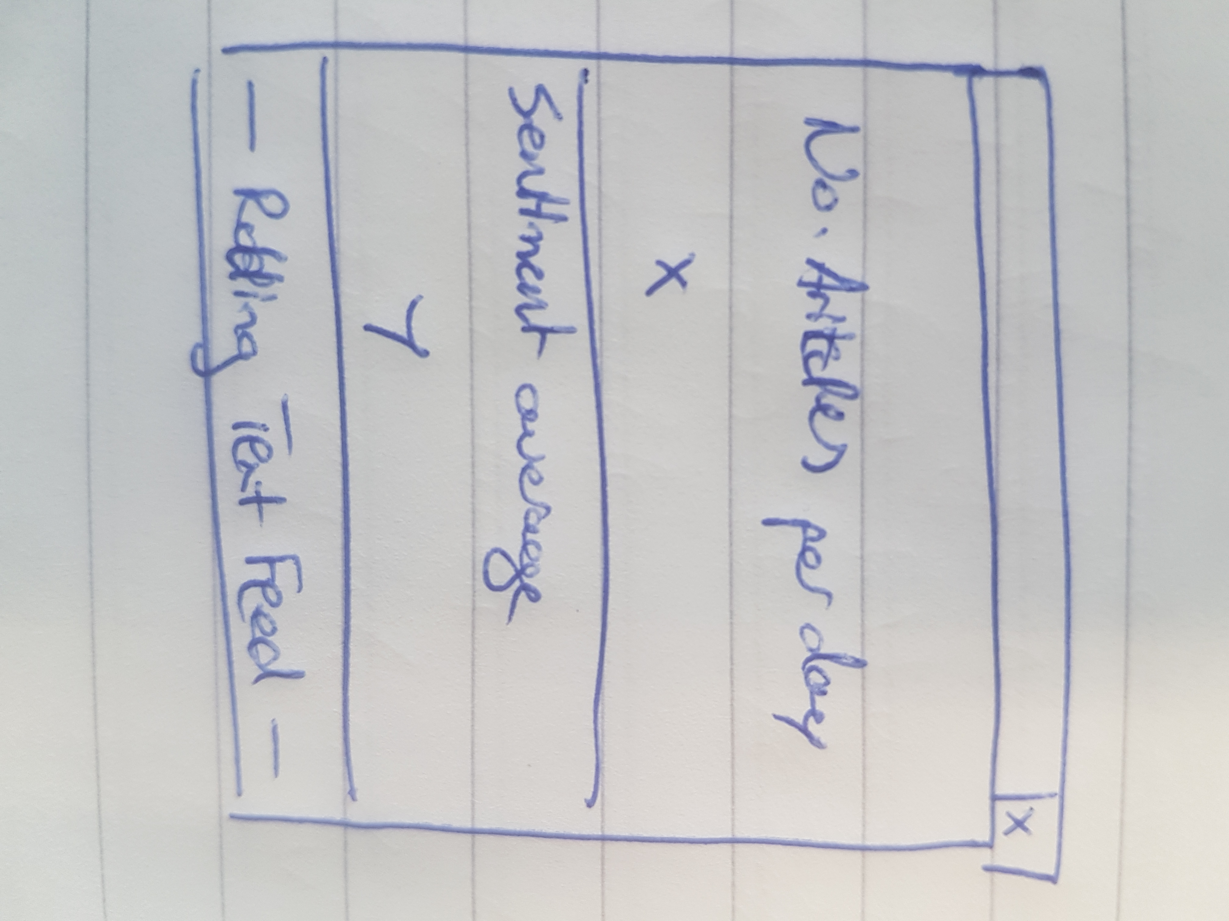
As discussed in the introduction, there are several restrictions to the design of this project: data displayed must be meaningful and contextualised, the application must be intuitive and simple to use, and the form factor of the design must be minimal to reduce the impact on screen space and workflow.
In addressing these issues, a basic project specification was agreed upon. This project is to produce a small window designed to sit in the corner of the user’s screen. This window is to be divided in two between the top half and the bottom half, the top displaying the number of articles published in a given time period and bottom showing the average ‘positive’ sentiment value of those articles. Initially this time period was set to per hour, but this proved to dilute the number of articles published beyond meaningful results, and so the design adapted to update on daily intervals.
The lower half of the window (the sentiment value portion) should dynamically change colour from red to yellow to green depending on whether the ‘positive’ sentiment Z-score is negative, neutral, or positive. These values and colours should update automatically and provide the user with some intuitive information regarding the nature of the data at a glance.
Stretch goals of providing additional data visualisation and a rolling text feed of headlines published in the given time period were also added to further contextualise results.

Implementation

Explanation of chapter structure and goals

Server-side

In order to fulfil this design specification, several layers of development are needed to satisfy the execution algorithm: the sentiment values will need to obtained, then processed and refactored for ease of treatment; the given data will need to be transmitted by a server to a client using HTTP requests (websockets were also considered but HTTP preferred due to the infrequency of daily requests); a client will then receive the data, parse it, and update the relevant elements of the webpage outlined in the design phase. The following chapter of this project describes the process by which this outline was implemented.
Having built our sentiment lexicon with Rocksteady and acquired our source text of Irish newspaper publications relating to ‘Garda’ and ‘Crime’ from LexisNexis, the next step is to acquire our sentiment analysis results by entering our dictionary and source text into Rocksteady. This produces a set of sentiment value Z-scores across the range of categories specified in the police_crime dictionary.
Using the tools provided by Rocksteady, these results are first grouped individually (each set of Z-scores relating to a single article). From this, articles are sorted based on their Z-score for relevance to ‘garda’ and articles with a Z-score of less than 0 in this category are removed to ensure only the most pertinent results remain. These filtered results are then regrouped by day, so that each day relates to a set of sentiment Z-scores for each category in the police_crime dictionary. The resulting sentiment values are then exported to a .CSV file for further processing. Unfortunately, this process is manual as there is no API provided for automatically interacting with Rocksteady. Below is a sample of results (stored in .CSV) for articles published between February 13th and 20th in Irish regional and national newspapers:

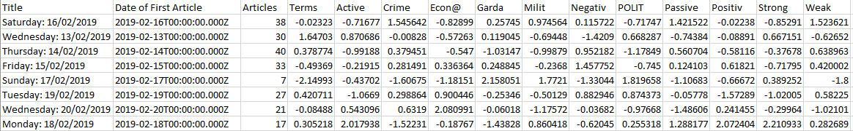

Having obtained a .CSV file of sentiment values for a particular set of articles, the next step is to process this information in preparation for sending it from the server to the client. The Parser.py program was written in python with a view of potentially being extended for natural language processing. This program can be executed by navigating to the file’s location in the command line and entering the command ‘python Parser.py “<sentiment-values>.csv”’ where <sentiment-values> is replaced with the name of the target file. The Parser will then load the contents of the given .CSV into a Python dictionary and convert that dictionary to JSON and saving it to file, if no file already exists, or appending the results to a previously created file taking care not to duplicate any overlapping values. The filepaths are created using Python’s pathlib library, meaning they function correctly with Windows, Linux, and Mac filepath formats. Below is a sample JSON entry acquired via this process:

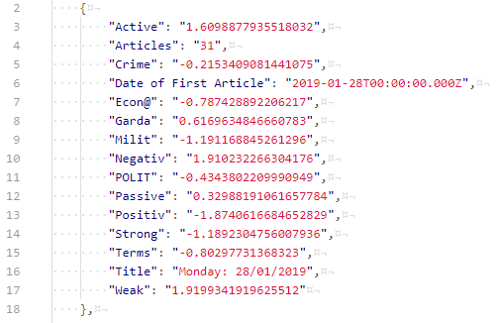

Parser.py also provides the filterJSON function shown below, which takes a datetime object and a datetime.timedelta object indicating the tolerable number of minutes away from the datetime a sentiment value can be (for example, a timedelta of 30 would mean half an hour either side of a give date and time). This function will prove useful when the server is responding to HTTP requests.

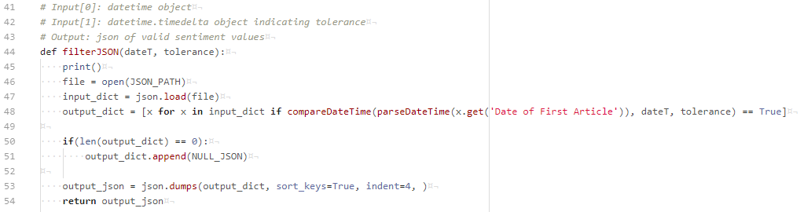

Now that the data has been acquired, parsed, and made searchable, it is time to implement the server. While the Python libraries urllib and httplib were initially dabbled with, the web microframework Flask was eventually turned to for its brevity and ease of use. Once the Flask application has been set up (only a few lines of code), the following snippet is all that is needed to establish a route for sentiment requests, specify the operations be performed, and respond with JSON sentiment value entries appropriate for the given Datetime and tolerance variables, both passed to the server through the HTTP request URL.

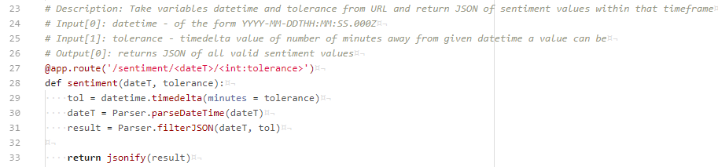

A route for requesting article headlines was also created but does not respond with meaningful data as this stretch goal was not implemented. For a time, it was thought a natural language processing program would be needed to acquire article headings from the source text as Rocksteady did not seem to parse them, however it was later learned that article titles are provided when sentiment values are grouped individually by Rocksteady. This may be an avenue for expansion in the future.
The server can be started by navigating to the containing folder in the terminal and running the command “python flaskServer.py”.

Client-side

While the design specification of the project left a lot to be interpreted for the server-side code, the requirements of the client-side are much more defined: a small window split between the number of articles published and the average positive sentiment of those articles, dynamically updated and colour-coded in accordance with the newest data received, with the stretch goal of providing further visual contextualisation of the given data.
It was decided that a combination of HTML, CSS, Javascript would be used to create a web application to be run through Electron as though it were a desktop application, regardless of the user’s platform. The first step of this process is to create the web pages to be rendered through Electron, starting with the ‘index’ (or ‘home’) page.

INDEX PAGE

This is to be the first page rendered and will provide the functionality of displaying the number of articles published and average positive sentiment value of those articles, and colour-coding the sentiment section.
To achieve this a webpage was described as two rows, the first a heading of “Articles per day” with a sub-heading containing number of articles produced, the second titled “Sentiment average” with a sub-heading of the value of the sentiment average. An extra data point of “change” was added to each sub-heading, to contextualise the current value by giving its difference to the previously held value.

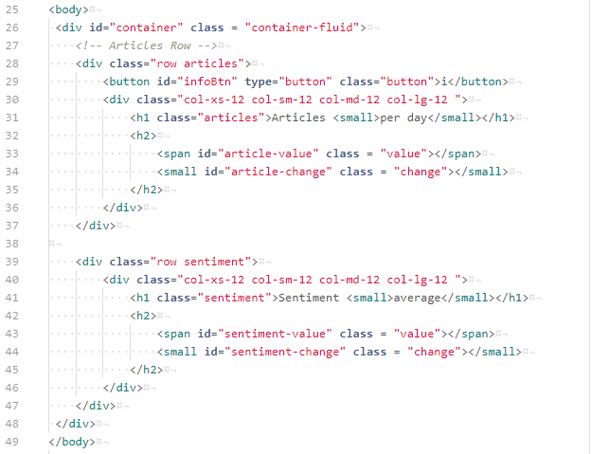

An “infoBtn” button element was later added to enable opening the information page. The exact nature of its operation will be described later.
A ‘home.js’ Javascript program provides the backend functionality. The algorithm of its execution involves ascertaining the document has correctly loaded using the jQuery(document).ready() function. Following this, a URL for acquiring sentiment values on a given date and time, with a given time tolerance, is created. jQuery is again used to create a HTTP GET request for the given URL. When the server has responded with sentiment values filtered for compliance with the given date and time restrictions, the returned data is parsed into JSON and stored for later reference (12 sentiment value entries, initially null entries, are stored at any one time). The data and background colours relating to sentiment and number of articles published are then updated.

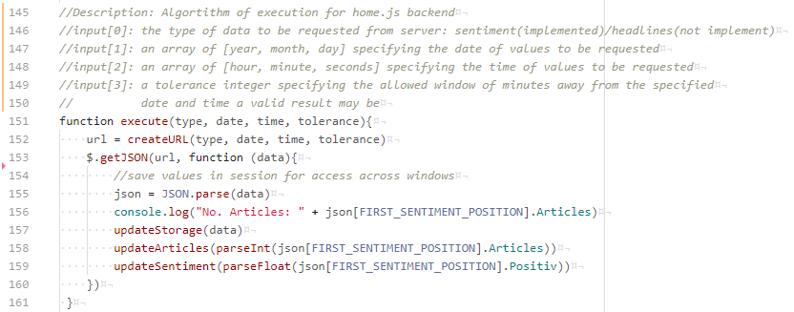
The update functions are performed using jQuery library functions to access and manipulate the relevant elements. The change values are calculated by taking the difference of the current and previous positive sentiment/number of articles values. The updateSentiment function also affects the background colour of the sentiment portion of the window. The RGB value of the colour to be displayed is calculated with using the following formula:

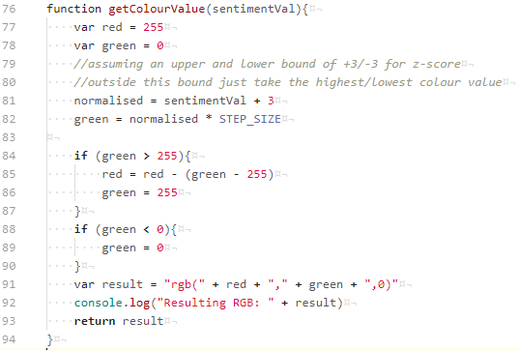

Where the STEP_SIZE is given as 255/3 (the maximum RGB value divided by 3), meaning that any sentiment Z-score greater than 3 or less than -3 is taken to be absolutely green or absolutely red. Taking the example of a Z-score of 0, the score is normalised to 3 and multiplied by the STEP_SIZE to produce a green value of 255 and a red value of 255, meaning a neutral Z-score results in a yellow background colour.

INFO PAGE

To provide further background information such as a variety of sentiment values (‘Garda’, ‘Crime’, ‘Political’, etc.) obtained through Rocksteady and a visual representation of their history and correlation, it was decided to include an information page of a line chart. The HTML for this page simply contains a ‘chart’ canvas, which the backend fills with a dynamic line graph drawn with Chart.js that displays the last 12 days’ worth of values for the categories of ‘Positive’, ‘Negative’, ‘Political’, ‘Garda’, ‘Crime’, ‘Strong’, and ‘Weak’ and updates automatically with a visual animation each time new values are received. Individual data categories can be focused by clicking on unwanted labels in the legend which hides the related lines using the following function:

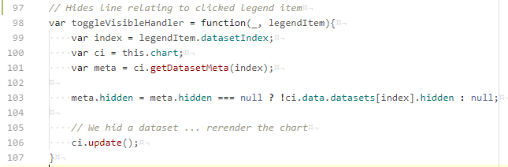

Styling for both the information and home page is performed by a single ‘styles.css’ stylesheet.

ELECTRON MANAGER

Now that the webpages have been defined, the functioning of the Electron app needs to be specified so that the correct windows are loaded. Working with Electron proved the most headache-heavy section of this project, with several unforeseen difficulties whose natures and solutions will be detailed here. However, the exchange of this effort for a cross-platform solution which does not require a client to disrupt their workflow to open a browser and provides control of various window functionalities was deemed worthwhile.
PROBLEMS HERE The first problem encountered was that of enabling jQuery within a webpage loaded in the Electron browser. Initially jQuery functions were running when tested within a browser (Chrome) and failing when run within Electron. Thankfully, Electron is widely used and a solution (small adjustment to HTML code) was eventually discovered to be documented.
Next there was the issue of creating a second window to display the information page when the information button is clicked on the homepage. As this operation cannot be performed within the homepage, when the button is clicked a message is send to the main Electron program instructing it to open a second child window (meaning when the home window is closed, so too is its child) loading the information page. 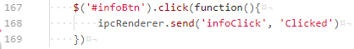
The final problem presented by Electron was enabling the transmission of data between multiple windows. Initially it was thought the standard web development solution to accessing data from multiple tabs using Javascript’s sessionStorage would suffice, however having multiple windows effectively means multiple browser, which sessionStorage cannot share data across. Eventually this issue was solved using Electron’s messaging functionality to send data as messages between the two windows. This will be described in more detail later.

In incorporating the webpages into Electron, it is necessary to create a ‘main.js’ program to manage the windows and their behaviour. On opening the application, the homepage (or ‘index.html’) should be loaded, and on the closure of all windows the application should end. This is achieved thusly:

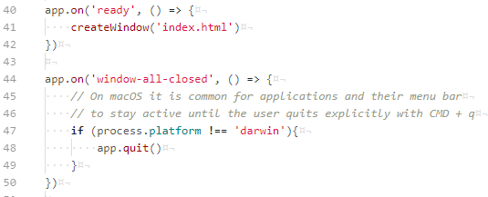

With the index page loaded, the Electron manager needs to listen for messages stating that the information button has been clicked and that a new window needs to be opened.

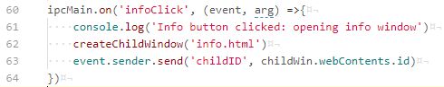

The final line of this listener sends the ID number of the created child window to the homepage. This allows the homepage to send the datasets required by the chart directly to the information page. Without using this ID number, a solution would involve an unnecessarily labourious and complex system of sending dataset messages to the the main Electron manager which would then transmit them over a channel for all windows to listen on.
With the Electron window manager, webpages, and associated backend set up we have defined the following algorithm for frontend operations:

- The application is opened (can be run using ‘npm start’ in cmd line from containing folder, or packaged with Electron and run as an executable).
- When the application is ready, an initial window is created and the ‘index.html’ webpage is loaded.
- The ‘index.html’ page requests and receives sentiment value entries from the server and updates the appropriate HTML elements accordingly.
- If the information button is clicked, an event is sent to the Electron app instructing it to create a child window of the information page.
- The information window is loaded and a line chart displaying a history of sentiment values is rendered.
- As new sentiment values are received, the homepage transmits the new datasets to the information page, and the line chart updates dynamically.
- Should the labels in the legend be clicked, the visibility of the related lines is toggled.
- On closing the home window, the information window is also closed, and the application quits.

Results

The design restrictions on this project as outlined in chapter XXXXX was to create an unintrusive application of small form factor to convey meaningful, contextualised information in an intuitive and easily digestible manner to an untrained Garda Press Officer operator. The resulting home screen can be seen below:

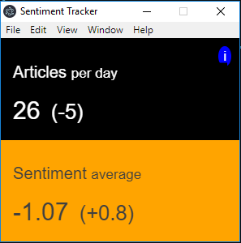

As shown, the project requirements of a split window divided between automatically updating ‘Sentiment average’ and ‘Articles per day’ values with dynamically updating colour-codes have been completed. The added ‘(change)’ values serve to further contextualise the data in relation to previous values, and the dynamic colour changes allow an operator to recognise when attention is needed at glance, encouraging a smooth workflow and informative interaction. The uncomplicated nature of the design allows the window to compressed into a small space (300px * 300px), meaning the busy screen space of a Garda Press Officer is largely unaffected.

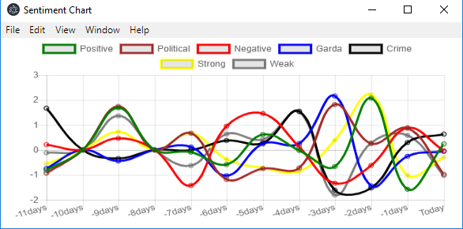

On clicking the blue information button in the top-right corner of the home screen, a new window (600px * 300px) is opened where the user is met with a line chart of sentiment Z-score values for the categories of ‘Positive’, ‘Negative’, ‘Political’, ‘Garda’, ‘Crime’, ‘Strong’, and ‘Weak’ collected over the previous 12-days. This serves as a visual history to provide further context for the given results, and an opportunity for a more finely-grained investigation into the correlation between different sentiment categories. Mousing over a data point in the graph will display a tag stating the associated X and Y values, as well as the line’s label.
Should the user wish to narrow the selection of datasets displayed for closer inspection, simply clicking on the coloured labels within the legend will result in the associated line’s visibility being toggled as shown below:

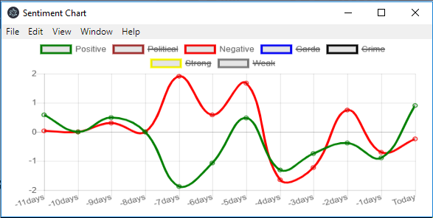

The straightforward nature of this design, along with the pleasant presentation and animation Chart.js provides, is hoped to provide the user with an intuitive and easy to digest experience that provides meaningful information quickly.

Evaluation

While the requirements of the design specification of this project has been met, along with the stretch goal of providing additional data visualisation in the form a chart page, have been met, it is still necessary to ascertain that this designs fulfils the client’s needs. To this end Shane Finan was kind enough to provide feedback on the product of this development process.

Conclusion
-difficulties faced
-future work
-concluding remarks

References

Ronen Feldman 2013

GARDA SIOCHANA WEBSITE REFERENCES (CRIMES https://www.garda.ie/en/Crime/
and hierarchy
https://www.garda.ie/en/about-us/organisational-structure/ )

Bing Liu 2012

THE OTHER ONE

Appendices

Appendix A

